**Extro Concealed Diverter Body for Single Lever (3-inlet)**

**Product Description:**

This Extro concealed diverter body is a premium-quality brass fitting designed for 3-inlet single lever mixers, offering efficient switching between shower, spout, or hand shower in a sleek, wall-concealed setup.

**Key Features (Single-line format)**

✅ 3-inlet design for multi-outlet configurations  
✅ Heavy-duty brass construction ensures durability  
✅ Leak-proof ceramic cartridge for long-lasting performance  
✅ Compact body for concealed wall installation  
✅ Compatible with most designer trims and plates

**Product Specifications**

**Brand:** Extro  
**Model:** Concealed Diverter Body (3-inlet)  
**Material:** Brass body with chrome-plated exposed handle  
**Finish:** Natural Brass (body), Chrome (lever/cover)  
**Inlet Connections:** 15 mm BSP (Hot, Cold, Outlet)  
**Control Type:** Single Lever (Ceramic Disc Cartridge)  
**Mount Type:** Wall Concealed  
**Compatibility:** Compatible with multiple external trim kits  
**Use:** Suitable for shower systems with diverter functions  
**Warranty:** Typically 5 Years(Verify with dealer)

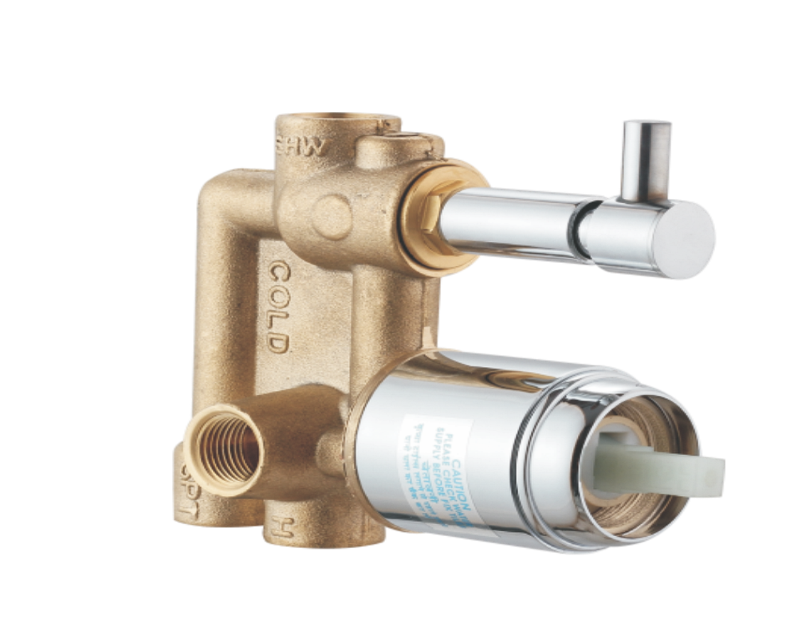

**Extro Concealed Divertor Body for Single Lever (2-inlet)**

**Product Description:**

This Extro concealed divertor body is designed for single lever mixers with 2 inlets, allowing seamless switching between two water outlets while keeping the plumbing concealed for a clean, modern bathroom design.

**Key Features (Single-line format)**

✅ 2-inlet system for dual outlet control (spout/shower)  
✅ Durable solid brass body for long-term use  
✅ Smooth ceramic cartridge for effortless lever control  
✅ Space-saving concealed installation  
✅ Compatible with standard designer faceplates

**Product Specifications**

**Brand:** Extro  
**Model:** Concealed Diverter Body (2-inlet)  
**Material:** High-grade brass with chrome-plated actuator  
**Finish:** Natural Brass (body), Chrome (handle unit)  
**Inlet Size:** 15 mm BSP (Hot, Cold)  
**Outlet Configuration:** 2-way (typically overhead and hand shower/spout)  
**Mount Type:** Wall Concealed  
**Operation:** Single Lever (ceramic disc cartridge)  
**Application:** Ideal for modern bathrooms and compact setups  
**Warranty:** Typically 5 Years(Verify with dealer)

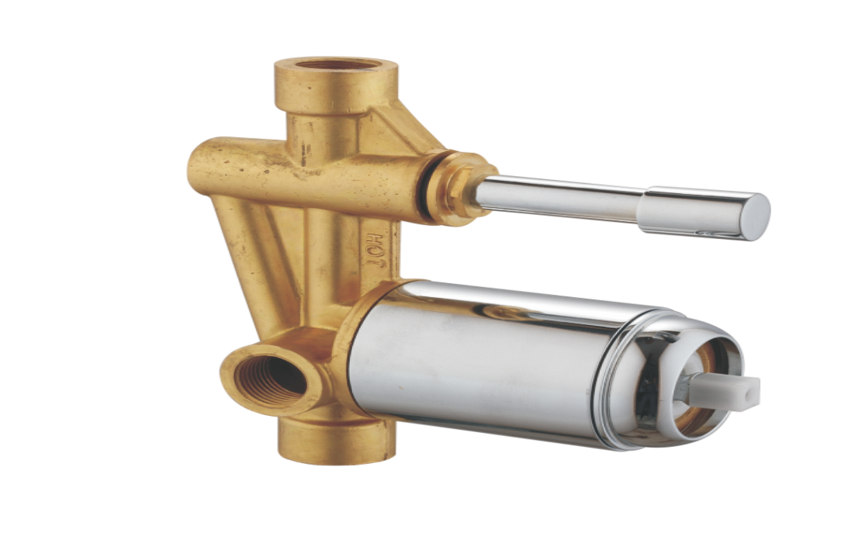

**Extro Single Lever Concealed Divertor Body (3-Inlet)**

**Product Description:**

This Extro concealed divertor body is engineered for use with a single lever mixer, featuring 3 inlets (typically hot, cold, and shower head) to manage complex water routing in modern bathrooms with seamless wall integration.

**Key Features (Single-line format)**

✅ 3-inlet design for enhanced water routing versatility  
✅ Sturdy brass body ensures corrosion resistance  
✅ Smooth-operating ceramic disc cartridge  
✅ Chrome-finished actuator for a premium look  
✅ Easy to install, compatible with standard faceplates

**Product Specifications**

**Brand:** Extro  
**Model:** Single Lever Concealed Divertor Body (3-inlet)  
**Material:** High-quality brass with chrome actuator  
**Finish:** Natural brass with chrome detailing  
**Inlet Size:** 15 mm BSP (Hot, Cold, SHW)  
**Outlet:** Typically to showerhead or tub spout  
**Mounting:** Wall Concealed  
**Operation:** Single Lever with ceramic disc cartridge  
**Use Case:** Suitable for overhead + hand shower or shower + tub setups  
**Warranty:** 5–10 Years (manufacturer dependent)

